Binary spits 🡪 false

Unpruned 🡪 false

Confidence factor 🡪 0.25

Minimal number of objects 🡪 2

Cross validation on training:

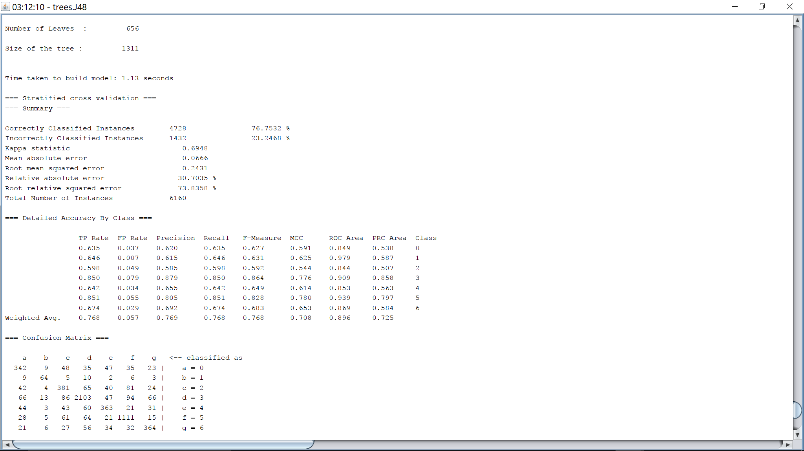

On testing set:

